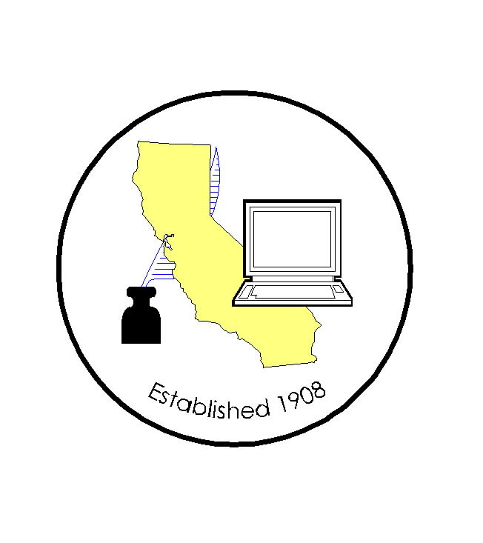
CALIFORNIA ASSOCIATION OF

CLERKS AND ELECTION OFFICIALS

April 15, 2009

TO: CACEO Members, Guests, Legislative Committee

FROM: Deborah Seiler and Jill LaVine, Co-Chairs

SUBJECT: CACEO LEGISLATIVE COMMITTEE MEETING

DATE: FRIDAY, April 24, 2009

TIME: 9:00 a.m. – 2:00 p.m.

LOCATION: Secretary of State’s Office – Multipurpose Room
1500 11th Street
Sacramento, CA 95814

SUBCOMMITTEE MEETINGS - Thursday, March 12, 2009

1 pm – 3 pm Provisional Voters – Lindsey McWilliams, Diane Jones, Co-Chairs
Board Room, Secretary of State’s Office

Upon adjournment of Friday’s meeting: HAVA/Certification – Tim McNamara, Chair

LEGISLATIVE COMMITTEE – Tentative Agenda

9:00 am Welcome and Introductions
Approval of Minutes of March 13, 2009 meeting

News from our City Clerk Representative

9:30 am Discussion of Bills
AB 106 Price AB 1356 Berryhill
AB 269 Silva AB 1424 Knight
AB 308 Cook AB 1519 De La Torre
AB 330 Saldana SB 34 Corbett
AB 441 Hall SB 172 Florez
AB 624 Monning SB 288 Yee
AB 686 Ruskin SB 321 Benoit
AB 742 Saldana SB 387 Hancock
AB 780 Perez SB 541 Pavley
AB 895/AB 909
AB 1096 Galgiani
AB 1121 Davis
AB 1228 Yamada
AB 1271 Krekorian
AB 1308 Hagman

AB 1335 Lieu
AB 1337 Evans
Category E (military): AB 1340; AB 1367; AB 1415; SB 370;
SB 582

Noon Lunch on Your Own`

1:00 pm Subcommittee Reports
Report on Federal Legislation

2:00 pm Adjourn

UPON ADJOURNMENT: HAVA/Certification Subcommittee will meet for two hours.

